
SCHOOL OF SCIENCE AND TECHNOLOGY

CLOUD-BASED GAME RECOMMENDER SYSTEM
by
JEDUTHUN AGHARESE IDEMUDIA
in
2024

Project report in part fulfilment
of the requirements for the degree of
Bachelor of Science with Honours
In
Software Engineering/ Information Systems/ Computer Science/ Cyber Security……….

I hereby declare that I am the sole author of this report. I authorize the Nottingham Trent University to lend this report to other institutions or individuals for the purpose of scholarly research.
I also authorize the Nottingham Trent University to reproduce this report by photocopying or by other means, in total or in part, at the request of other institutions or individuals for the purpose of scholarly research.

Signature
Jeduthun Agharese Idemudia

ABSTRACT
This project endeavours to develop a cloud-based game recommender system specifically tailored for video games, leveraging collaborative filtering techniques to predict user preferences based on historical data and similarities with other users. The system is encapsulated within a Docker container for enhanced portability and scalability and deployed on Microsoft Azure using the Azure Kubernetes Service (AKS), ensuring robustness and high availability. An interactive user interface is developed with Streamlit, an open-source framework, facilitating an engaging user experience with the incorporation of Redis – a NoSQL database.
The deployment architecture utilities AKS for container orchestration across a Kubernetes cluster, with an Ingress service functioning as a load balancer to efficiently distribute incoming requests and maintain a stable access point for users. Docker is used for the container registry. The primary aim is to deliver personalized game recommendations that align with individual user tastes, thereby augmenting user engagement and facilitating game discovery.
Moreover, the system is designed with adaptability in mind, allowing for potential future expansions to encompass additional content types, such as music and e-commerce products. An ambitious goal is the integration of an online recommendation algorithm to offer dynamic, real-time recommendations, further personalizing the user experience. Through the integration of cloud computing, containerization, and advanced machine learning algorithms, this project sets a precedent for the development of next-generation recommender systems.

ACKNOWLEDGEMENTS

TABLE OF CONTENTS
ABSTRACT 3
ACKNOWLEDGEMENTS 4
CHAPTER 1 6
INTRODUCTION 6
1.1 Introduction 6
1.2 Background Literature 6
1.3 Problem Identification 7
1.4 Wider Topic Placement 7
1.5 General Project Implications 7
1.6 Aims and Objectives 8
Chapter 2 9
CONTEXT 9
2.1 Literature Review 9
Collaborative filtering 9
Performance Evaluation of Collaborative Filtering 9
Economic & Social Implications of Recommendation Systems 10
Taxonomy of Recommendation Techniques 10
Survey of Recommendation Algorithms 11
Scalability on Cloud Platforms 11
Economic Impact on Indie Developers 11
2.2 Primary Research 12
2.3 Existing Solutions 12
Collaborative Filtering Techniques 12
Content-Based Filtering Approaches 12
Hybrid Systems 12
Evaluation and Performance Metrics 12
Economic Impact Analysis 13
Scalability and Cloud-Based Solutions 13
Emerging Technologies and Future Directions 13
2.4 Case studies 15
CAREER ASPIRATIONS 15
LSEPIs 15
REFERENCES 15

CHAPTER 1

INTRODUCTION

1.1 Introduction
The gaming industry has experienced an unparalleled transformation over the last few decades, evolving from simple pixelated games to complex, immersive worlds that span across a multitude of genres, platforms, and delivery methods. This evolution has been significantly accelerated by the advent and proliferation of cloud gaming services, fundamentally altering how games are distributed, accessed, and played. Amidst this rapid growth and the resultant expansive library of available games, the challenge of discovering games that align with individual preferences has become increasingly pronounced. In response to this challenge, the development of a Cloud-Based Game Recommender System represents a pivotal advancement, offering a solution to personalize game recommendations in an era characterized by digital abundance.

1.2 Background Literature
The conceptualization of this project is deeply rooted in the extensive body of literature surrounding recommendation systems, cloud computing, advanced machine learning algorithms and the dynamics of the gaming industry. The principle of collaborative filtering, a method that filters for items that a user might like based on reactions by similar users, has been a cornerstone in the development of recommendation systems across various domains. The seminal work by Goldberg et al. (1992) on using collaborative filtering to create mail filters laid the groundwork for the application of these algorithms in broader contexts, including the gaming industry. Furthermore, the integration of content-based filtering techniques, which suggest items based on the content’s attributes and a user’s preferences, has been instrumental in refining recommendation accuracy and relevance.
Parallel to these developments in recommendation systems, the emergence of cloud computing has offered a scalable, efficient platform for processing and analysing vast datasets, essential for powering complex recommendation algorithms. Mell and Grance’s definition (2011) of cloud computing as a model for enabling ubiquitous, convenient, on-demand network access to a shared pool of configurable computing resources underscores the transformative potential of cloud technology in managing the data-intensive demands of game recommender systems.

1.3 Problem Identification
The proliferation of games across genres and platforms, coupled with the digitization of game distribution through online platforms, has created a paradox of choice for gamers. As Teng (2018) points out, the overwhelming variety of games can lead to decision fatigue, making it difficult for gamers to find titles that genuinely match their interests and preferences. This challenge is exacerbated by the dynamic and fast-paced nature of the gaming industry, where new titles are constantly released, and trends shift rapidly.

1.4 Wider Topic Placement
This project is situated at the intersection of the gaming industry's evolution and the revolutionary impact of cloud computing on digital services. As cloud-based gaming platforms, such as Google Stadia and NVIDIA GeForce NOW, gain traction, they not only change the game distribution landscape but also heighten the demand for personalized game discovery tools. By leveraging cloud infrastructure's computational power, the Cloud-Based Game Recommender System aims to process extensive game metadata and user interaction data, offering customized recommendations that enhance the gaming experience.

1.5 General Project Implications
The implications of a successful cloud-based game recommender system extend beyond individual gamers. For game developers and publishers, such a system can drive discoverability and engagement for their titles, potentially translating into higher sales and user retention. Moreover, the principles and methodologies developed through this project can contribute to the broader field of recommendation systems, with applications ranging from e-commerce to content streaming.
In conclusion, by addressing the contemporary challenges of game discovery through a cloud-based recommender system, this project not only contributes to enhancing the individual gaming experience but also offers valuable insights and tools for the gaming industry at large. This initiative is a step towards realizing the full potential of cloud computing in personalizing digital content consumption, marking a significant advancement in the intersection of technology, entertainment, and user-centric design.

1.6 Aims and Objectives
Aim: The primary aim is to deliver personalized game recommendations that align with individual user tastes, thereby augmenting user engagement and facilitating game discovery. This project will be utilising collaborative filtering technique in dealing with the recommendation algorithm.
Objectives:
Data Collection and System Setup:
- Create user profiles and gather game data.
- Set up a cloud-based data storage and processing infrastructure.
- Ensure data privacy and security measures.
- Develop data collection scripts and processes.
Recommendation Algorithm Development:
- Develop the recommendation algorithm.
- Test and validate the algorithm for accuracy.
- Utilize cloud-based machine learning resources.
- Incorporate user gaming history, preferences, and reviews.
User Interface and Integration:
- Design a user-friendly interface.
- Ensure system performance for 20 simultaneous users.
- Seamlessly integrate the recommendation algorithm.
- Implement user-centric features.
Testing and Optimization:
- Conduct comprehensive testing, including A/B testing.
- Optimize system responsiveness and accuracy.
Scalability and maintenance:
- Ensure the system can accommodate a growing user base and game library.
- Aim for increase in system capacity.

Chapter 2

CONTEXT

2.1 Literature Review
This chapter describes the foundational concepts applied to the game recommender system, including its goal and the research material used. A broader context on recommendation systems is studied, relating the goal of this project to the fundamentals of recommendation systems in general. With the field of game recommendation systems witnessing significant growth in recent years and being driven by advancements in artificial intelligence, cloud computing, and data analytics the important contributions that led to this feat will also be investigated. This literature review provides an overview of key research contributions in this domain, encompassing both theoretical frameworks and practical implementations.

Collaborative filtering
Collaborative filtering as a foundational concept in recommendation systems was first introduced by Goldberg et al. (1992) in the article “Using collaborative filtering to weave an information tapestry”. Their work laid the groundwork for collaborative-based approaches, which leverage user preferences and similarities to generate personalized recommendations. This method has since been widely adopted in the design of game recommender systems. This method assumes that those who agreed in the past will agree in the future about their preferences. The introduction of collaborative filtering marked a significant shift in how recommendation systems were conceptualized, moving from content-based recommendations (which rely on item attributes) to user-based recommendations (which rely on user behaviour and preferences). This approach has become a cornerstone of modern recommendation systems, including those used in gaming, where understanding and predicting user preferences are crucial.

Performance Evaluation of Collaborative Filtering
Herlocker et al. (2000) conducted a seminal study on the performance of collaborative filtering algorithms in movie recommendation systems. While their focus was on films, their findings are highly relevant to game recommendation systems due to the similarities in user preferences and content consumption patterns across both media types. The researchers created a conceptual model for developing explanations which provided a mechanism for handling errors that come with a recommendation. With the use of traditional usability evaluation methods, they found that users preferred explanations based on neighbour ratings, recommender system performance, item similarity to other highly rated items, and appearance of favourite actor or actress. Users were more likely to watch a recommended movie, according to their estimates. The evaluation frameworks and findings from Herlocker et al.'s study are directly applicable to game recommendation systems. They underscore the necessity of robust evaluation metrics and highlight the potential for collaborative filtering to enhance user engagement through personalized game recommendations.

Economic & Social Implications of Recommendation Systems
The economic implications of recommendation systems in e-commerce, highlighting their potential to increase user engagement and drive sales was further investigated by Resnick and Varian (1997). Resnick and Varian explored how recommendation systems could drive economic benefits in e-commerce by enhancing user engagement and facilitating sales. This perspective is crucial for understanding the broader impacts of recommendation systems beyond user satisfaction. Applying these insights to the gaming industry suggests that effective game recommendation systems can significantly impact player retention and monetization. By aligning game recommendations with user preferences, developers and platforms can increase sales and engagement, particularly in the competitive indie game market. Resnick and Varian (1997) also cover the social implications of recommender systems by introducing two incentive problems. The first being that once a user has built an interest profile, it is easy to free ride by consuming other people’s ratings. Even if evaluations are acquired indirectly from existing resources or by monitoring user behaviours, the problem is not fully resolved. According to Resnick and Varian, Future systems will most likely need to provide some incentive for the provision of recommendations either by making it a requirement for getting recommendations or by granting financial rewards. The second being that if anyone can provide recommendations, content creators may produce a slew of good recommendations for their own materials along with bad recommendations for competitors. According to Resnick and Varian, Future systems are expected to include precautions that discourage the “vote early and often” phenomenon.

Taxonomy of Recommendation Techniques
Burke (2010) introduced a taxonomy to categorize recommendation systems into content-based, collaborative, and hybrid models. This classification helps in understanding the range of approaches available for designing recommendation systems and their potential applications. For game recommendation systems, this taxonomy offers a framework for selecting the most appropriate techniques based on specific goals, such as improving accuracy, personalization, or scalability. Hybrid approaches, which combine content-based and collaborative filtering, may offer balanced benefits for gaming platforms seeking to optimize user experiences.

Survey of Recommendation Algorithms
Shani & Gunawardana conducted a comprehensive survey to provide an overview of various recommendation algorithms, including deeper dives into the mechanisms of collaborative filtering, content-based filtering, and matrix factorization techniques. Understanding these algorithms is essential for building and optimizing game recommendation systems. The review by Shani and Gunawardana equips developers with knowledge about the strengths and limitations of each algorithm, enabling them to tailor recommendation systems to the unique dynamics of game discovery and engagement.

Scalability on Cloud Platforms
Nguyen and Zhu's research addressed the scalability challenges of recommendation systems deployed on cloud platforms. They evaluated performance under different conditions, highlighting the importance of efficient algorithm design and resource management. As game recommendation systems need to handle vast datasets and serve millions of users, scalability becomes a critical concern. This study provides valuable insights into how cloud computing resources can be optimized for large-scale recommendation tasks, ensuring that recommendations remain responsive and accurate even under high demand.

Economic Impact on Indie Developers
Harrison & Riedl (2020) focused on the economic benefits of recommendation systems for indie game developers, analysing how personalized recommendations can influence sales and user engagement metrics. For indie developers, who often work with limited marketing budgets, effective game recommendation systems can level the playing field, allowing them to reach potential players more efficiently. This research underscores the value of recommendation systems not just for users but also for developers seeking to maximize their games' visibility and financial success.
Together, these studies provide a multifaceted view of the game recommendation system landscape, from theoretical foundations to practical applications and implications. They highlight the importance of continued innovation in recommendation algorithms and the need for a nuanced understanding of how these systems can drive economic value and enhance the gaming experience for users worldwide.

2.2 Primary Research
This primary research section explores the effectiveness and impact of game recommendation systems, leveraging insights from academic studies involving extensive participant data. It focuses on evaluating different recommendation algorithms, understanding user engagement, and assessing the economic benefits these systems bring to the gaming industry. By synthesizing quantitative and qualitative findings from previous research, this investigation aims to provide a nuanced understanding of current practices and highlight areas for innovation within game recommendation systems. The goal is to offer actionable insights that can enhance user experiences, improve engagement, and support the economic success of games in a competitive landscape.
User Behaviour and Preferences in Game Platforms
Personalised interactive systems are more successful than generic approaches, hence it is crucial to personalise game-based systems for each user. The gender and age differences in preference play an essential role in the personalisation of video games. González-González et al., (2022) conducted a survey with a total of 815 participants with 338 being female, 470 being male and 7 being other genders. The age and gender distribution can be seen below in the graph.
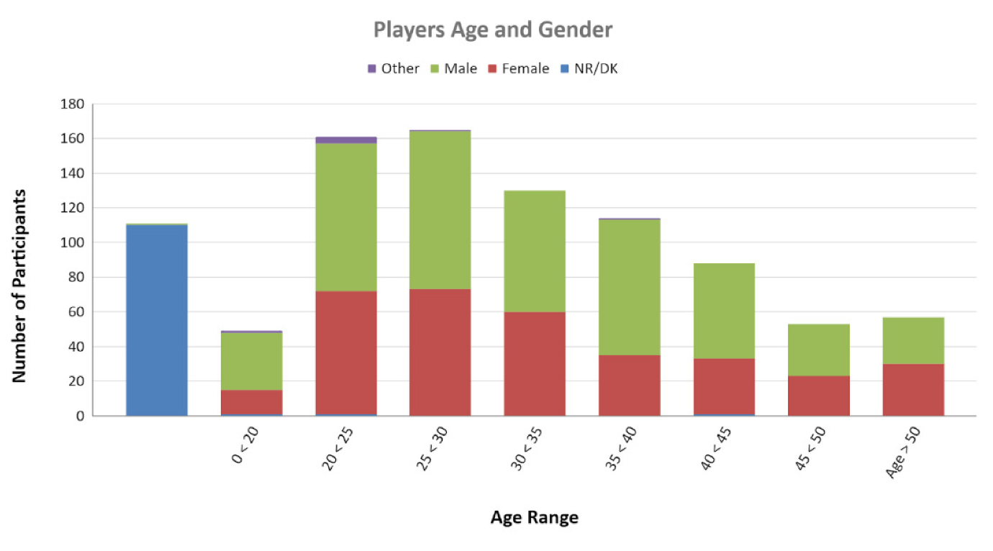
Figure 1 User behaviour & perference survey based on age and gender
During the survey, questions were asked like:
- “How many days in a typical week do you usually play games for at least 10 minutes?”,
- “Which of these platforms do you usually play?” with board games, Pc/Mac, tablet, smartphone, hand console and console being listed out,
- “Have you ever played a game that uses leaderboards (scoreboards on which the names, etc., of the leading competitors, are displayed)?”,
- “Have you ever played a game that uses teams (numbers of persons associated in some joint action)?”,
- “Have you ever played a game that uses challenges (explicitly tricky or demanding tasks, especially those seen as a test of one’s abilities or character)?”,
- “Have you ever played a game that uses a voting mechanism (the action of giving a vote: to exercise the right of suffrage to express a choice or preference by ballot or other approved means)?”
- “Have you ever played a game that uses gifting (to endow or furnish with gifts)?”,
- “Have you ever played a game that allows exploration (tasks built for the purpose of exploration, especially those constructed or selected for exploration or observation of the surrounding area)?”.
The questions asked above were trying to gage the type of devices the participants prefer to play as well as the participants experience with different elements. It was found that males dedicate more time to playing online games than female or other players with a 63.16%. According to platform, females preferred board games to every other platform with consoles being their least favoured platform. Tablets were evenly used between both genders. In terms of game elements, the use of gifting produced the greatest beneficial difference across genders. The most significant negative difference is related to the voting mechanisms as it was recognised 12.33% less by females while playing.
Regarding the age difference, it can be gathered that the type of gaming platform users prefer is highly influenced by age. Most technological platforms such as PC/Mac and hand-held consoles were preferred by the younger ages. While that of the older users preferred board games, tablets, and smartphones. Middle-aged players from 30 to 35 preferred consoles.
In terms of game elements, the variations across age intervals appear to be considerably smaller and not significant for the majority of the analysed aspects, with "challenges" being one of the game elements that can be notable in terms of age differences, decreasing in older individuals. Regarding age intervals, the usage of challenges is the only game element that has notable deviation. Most of the age gap correlate negatively with the game elements, while the younger and older do the opposite.
In conclusion, the paper provided a better understanding of player retention and their relationship with games. According to the gender, the female participants prefer board games to other platforms and significantly played less games per week in respect to their number. As the male participants played more games per week which can lead to the conclusion that the male participants are more likely to make use of this project. The age of participants also highly influenced the intensity to the use of games per week. With the younger ages, significantly higher than the older ages. This can lead to the conclusion that this project will be made use of by the younger generation.
Collaborative Filtering in Online Gaming
Collaborative filtering (CF) with user ratings accurately predicts user preferences for item selection. In the late 1990s, recommender systems were popularised by internet services like Amazon, Yahoo! Music, and Netflix, leading to a vibrant sector of machine learning. When creating recommendations, there are two fundamental techniques. One involves profiling users and items by distinguishing their features, such as demographic data for user profiling and product description for item profiling. The other approach involves using solely previous user activity, such as transaction history or user satisfaction ratings. The former is the content-based approach, whereas the latter involves collaborative filtering. Collaborative filtering is typically more viable because the content-based approach is often difficult to gather the necessary information and convince users to share their personal data to aid in the creation of profiling database. (Takács et al., 2009)
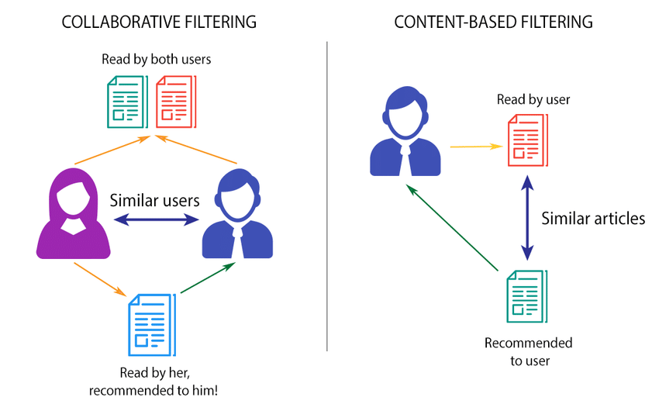
Figure 2 Collaborative filtering
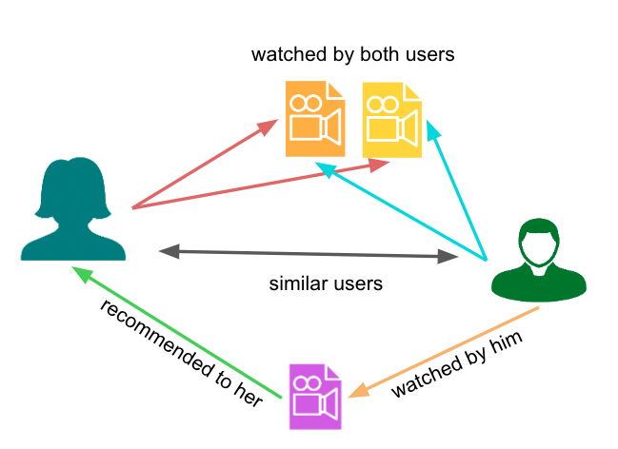
Figure 3 Collaborative filtering logic
According to Takács et al., (2009), Collaborative filtering can be applied as matrix factorisation and neighbour based correction of matrix factorisation, but it operates in two modes: user-based and item-based. User-based collaborative filtering recommends items by finding users similar to the target user, based on their historical preferences or activities. Item-based collaborative filtering, on the other hand, identifies items that are similar to those the user has previously liked or interacted with. In the context of online gaming, both approaches can be employed to recommend games that users are likely to enjoy, based on the behaviour and ratings of others. Studies in collaborative filtering for online gaming often involve analysing large datasets of user-game interactions, such as playtime, ratings, and purchase history. Advanced statistical models and machine learning algorithms are employed to extract patterns and predict user preferences. Typically, the steps involved in most studies include data collection, preprocessing, similarity measurement and recommendation generation.
While collaborative filtering provides a robust framework for recommendations in online gaming, it faces several challenges. A cold start problem can occur if new users or items provide insufficient interaction data which can hinder the effectiveness of collaborative filtering. Hybrid approaches that incorporate content-based features can help mitigate this problem. As the number of users and items grows, collaborative filtering algorithms can become computationally expensive which can lead to a scalability problem. Techniques such as dimensionality reduction, clustering, and matrix factorization are often used to improve scalability. Collaborative filtering tends to recommend popular items, potentially leading to a alack of diversity. Introducing novelty and diversity metrics into the recommendation process can enhance user discovery and satisfaction.
Collaborative filtering stands as a cornerstone of modern recommendation systems in online gaming, fundamentally shaping how games are marketed and consumed. Its ability to adapt to user preferences not only maximizes engagement but also drives the economic success of gaming platforms. Ongoing research and development in overcoming its limitations are crucial, as the technology continues to evolve in response to new challenges and opportunities within the gaming industry. This dynamic interplay between user data and recommendation technologies underscores the pivotal role of collaborative filtering in the ever-expanding realm of online gaming.

Content-Based Filtering Using Deep Learning
Content-based filtering (CBF) harnesses the attributes of items themselves—such as descriptions, tags, and other metadata—to make recommendations. In online gaming, this approach can be particularly effective due to the rich and diverse nature of game content, which includes genres, gameplay mechanics, graphics, and narratives. Deep learning, with its ability to handle large volumes of complex data, enhances content-based filtering by extracting more nuanced features from game data, leading to more personalized and accurate game. Traditional content-based filtering systems use simpler algorithms that might rely on explicit features like genre or developer to recommend games. However, deep learning can uncover latent features from game content, such as the mood of the game, complexity level, or even similarity in visual style, by analysing game descriptions, reviews, images, and videos.
Implementing content-based filtering with deep learning involves several steps. The first step in content-based filtering is feature extraction. In feature extraction, deep learning models, particularly convolutional neural networks (CNNs) for image data and natural language processing (NLP) models for textual data, are used to extract features from game content. The second step is model training. In model training, neural networks are trained on game data to learn representations that predict user preferences based on content features. This training involves defining a loss function and optimizing it using a large dataset of user interactions and game attributes. The final step is the recommendation generation. Once the model is trained, it can predict a user’s affinity for unseen games by comparing the deep learning-generated content features of new games with those of games the user has previously liked.

Figure 4 content-based filtering
Despite its advantages, content-based filtering using deep learning faces specific challenges. Content-based filtering can lead to recommendations that are too narrow, constantly suggesting games too similar to those a user has already played. This can cause over-specialization. To counteract this, methods like feature diversification and exploration techniques are integrated to introduce novelty and variety into the recommendations. Deep learning models require large amounts of data to perform well, which can be a limitation in scenarios where data is scarce or hard to process. Transfer learning and data augmentation are strategies used to overcome this challenge. Deep learning models are often considered "black boxes" due to their complexity, making it difficult to understand why certain recommendations are made. Techniques such as layer-wise relevance propagation (LRP) or attention mechanisms are used to improve model transparency.
Content-based filtering, augmented by deep learning, offers a powerful approach for personalized game recommendations in online platforms. By extracting deep, latent features from complex game data, these systems provide highly relevant and tailored game suggestions that improve user satisfaction and engagement. As technology advances, further enhancements in deep learning models will likely provide even more precise and enjoyable gaming experiences, driving the evolution of recommendation systems in the gaming industry.

Evaluation of Recommendation Algorithms
Online social networks have expanded over time from profile and communication websites to online portals where individuals connect with one another, exchange and make use of multimedia material along with playing a variety of games. Leroux et al., (2012) compares the performance of collaborative filtering algorithms to that of content-based algorithm and shows the end result of a combined approach i.e. a hybrid system. An online game dataset for “Gatcha!” was used to perform the comparison and evaluation of both algorithms. Regarding content-based filtering, the game category serves as the core game property. Game categories are simply the different genres assigned to games which include sports, arcade, action, shooter, etc. A list of recommended games is created based on a user’s last played game category. The list is split 50/50 between the most popular and newest games in that category. Whereas that of collaborative filtering uses neighbourhood models (k-NN) to interpolate a user-item preference matrix based on ratings of comparable users or objects. This approach predicts the ratings for unrated items based on ratings from similar users. From the evaluation results it was shown that neighbourhood-based collaborative filtering algorithm outperforms that of the content-based approach. The results also showed that a combined technique outperforms the two previous approaches in terms of evaluation metrics for all scenarios, with just a tiny performance disadvantage. With this research, a conclusion can be formed that the neighbourhood collaborative filtering method is the most appropriate for this project.

2.3 Existing Solutions
The literature review touches upon a broad range of topics within the realm of game recommendation systems, highlighting foundational work, key advancements, and several niche areas of investigation. The existing solutions and advancements in this domain, as discussed in the literature, encompass algorithmic developments, evaluation frameworks, economic analyses, and scalability considerations. A summary of these solutions and their contributions to the field is listed below:

Collaborative Filtering Techniques
Personalization and User Preference Modelling: Solutions based on collaborative filtering (CF) leverage user behaviour and ratings to predict future preferences. This technique has been pivotal in personalizing game recommendations by finding similarities among users and recommending games liked by similar users.
Matrix Factorization: A refinement within CF, matrix factorization models (such as SVD, ALS) improve recommendation accuracy by decomposing user-item interaction matrices into lower-dimensional representations, capturing latent factors associated with user preferences and item characteristics.

Content-Based Filtering Approaches
Game Attribute Analysis: Content-based filtering (CBF) solutions analyse attributes of games (e.g., genre, gameplay mechanics, themes) to recommend new games with similar characteristics. This approach is especially useful for recommending games within niche genres or for users with very specific tastes.
Natural Language Processing (NLP): NLP techniques have been applied to analyse game descriptions, reviews, and other textual data to enhance content-based recommendations, enabling more nuanced understanding and matching of game content to user preferences.

Hybrid Systems
Combining CF and CBF: Hybrid approaches integrate collaborative and content-based filtering to leverage the strengths of both. These systems can offer personalized recommendations based on both user behaviour and game attributes, mitigating the limitations of each approach when used in isolation.

Evaluation and Performance Metrics
Empirical Evaluation Frameworks: The work of Herlocker et al. and others has established comprehensive frameworks for evaluating recommendation systems, utilizing metrics like precision, recall, and F1 score. These evaluation methods help in assessing the accuracy and relevance of recommended games to users.
User Satisfaction and Engagement Metrics: Beyond accuracy, measures of user satisfaction, engagement (e.g., playtime, purchase rates), and retention have been employed to gauge the effectiveness of recommendation systems from a user-centric perspective.

Economic Impact Analysis
Monetization and User Engagement: Studies have explored the economic implications of recommendation systems, demonstrating their potential to enhance monetization through increased sales, in-game purchases, and sustained player engagement. This area of research highlights the direct business impacts of effectively implemented recommendation systems.

Scalability and Cloud-Based Solutions
Cloud Computing: Research into the scalability of game recommendation systems, as seen in the work of Nguyen and Zhu, addresses the challenges of handling large-scale data and serving millions of users. Cloud-based architectures enable dynamic resource allocation, ensuring the system remains responsive even under heavy loads.

Emerging Technologies and Future Directions
Machine Learning and Deep Learning: Advanced ML and DL models (e.g., neural networks, deep embedding models) are being explored to further improve recommendation accuracy and personalization by learning complex patterns in large datasets.
Social and Contextual Recommendations: Incorporating social network data and contextual information (e.g., time of day, current trends) offers new avenues for enhancing game recommendations by considering broader social and temporal dynamics.

Based on the comprehensive review of existing solutions in the domain of game recommendation systems, it's clear that certain approaches and methodologies have been well-received and show promise for enhancing user experience and driving economic benefits. However, it's equally important to recognize potential pitfalls and aspects that may not contribute effectively to this project's goals. Drawing conclusions from these insights can guide the development of the game recommender system.
Well-Received Ideas and Approaches
- Hybrid Recommendation Systems: Combining collaborative and content-based filtering approaches has been shown to offer a balanced and effective means of personalization. This hybrid model leverages both user behaviour and game attributes, addressing the cold start problem and improving recommendation diversity.
- Matrix Factorization Techniques: In collaborative filtering, matrix factorization techniques like Singular Value Decomposition (SVD) and Alternating Least Squares (ALS) have proven effective in uncovering latent factors that influence user preferences. These methods are well-regarded for their accuracy in predicting user-game interactions.
- Use of Advanced Machine Learning and Deep Learning: Incorporating ML and DL models to analyse complex patterns in user data and game attributes can significantly enhance the accuracy and personalization of recommendations. Techniques such as neural networks and deep embedding models are at the forefront of innovation in recommendation systems.
- Evaluation and User-Centric Metrics: Employing rigorous evaluation frameworks that focus on metrics beyond accuracy, such as user satisfaction, engagement, and retention, is critical. These metrics ensure that the system aligns with user needs and preferences, contributing to a more effective recommender system.
- Scalability and Cloud-Based Implementations: Ensuring that your recommendation system can scale effectively to handle large datasets and serve a wide user base is crucial. Cloud computing offers a flexible and efficient solution for managing resources and maintaining system performance under varying loads.
Things to Avoid in Design
- Over-Reliance on a Single Recommendation Approach: Solely depending on collaborative filtering or content-based methods can lead to limitations, such as the cold start problem or lack of diversity in recommendations. Avoiding reliance on a singular approach can mitigate these issues.
- Ignoring the Importance of Privacy and Data Security: When designing your system, it's vital to prioritize user privacy and secure handling of user data. Overlooking these aspects can lead to user distrust and potential legal challenges.
- Underestimating the Complexity of User Preferences: Users' gaming preferences can be influenced by a wide range of factors, including social influences, contextual factors, and temporal variations. A simplistic model that does not account for these complexities may fail to deliver personalized and relevant recommendations.
- Neglecting User Feedback Mechanisms: Failing to incorporate mechanisms for capturing user feedback on recommendations can hinder the system's ability to learn and adapt to user preferences over time. Continuous learning from user interactions is key to maintaining the relevance and effectiveness of recommendations.
- Lack of Testing and Iteration: Skipping thorough testing and iteration based on user feedback and performance metrics can result in a system that does not meet user expectations or achieve desired outcomes. Rigorous evaluation and willingness to iterate based on findings are essential for success.
In the implementation of this project the collaborative technique is employed to handle the user recommendations. Although there were certain things that were difficult to implement in the design like a hybrid system and user feedback mechanism, they could be included in the future design. These solutions and advancements collectively contribute to the ongoing development and refinement of the game recommender system. They not only enhance the user experience by providing more personalized and relevant game suggestions but also offer significant benefits to game developers and platforms through increased engagement, retention, and monetization. As the field continues to evolve, further research and innovation will likely address existing challenges and open up new possibilities for recommendation systems in gaming and beyond.

2.4 Case studies
While specific case studies on game recommender systems are vast and diverse, reflecting the unique challenges and solutions across different platforms and contexts, several notable examples stand out. These case studies illustrate the practical application of theories and technologies discussed in the literature review and highlight the outcomes of these implementations. Let's discuss a few seminal and illustrative case studies that offer valuable insights for anyone looking to develop or study game recommendation systems.
Steam’s Discovery Update
Valve's Steam platform, a leading digital distribution service for PC gaming, introduced the Discovery Update to improve game recommendations for users. The update implemented machine learning algorithms to personalize the storefront for each user, considering their past behaviour, preferences, and purchase history. The Discovery Update introduced features like the Discovery Queue, personalized game recommendations, and a more robust search function. It leverages user data, including playtime and ratings, to inform its recommendation algorithms. Post-implementation, Steam reported increased user engagement and sales, particularly benefiting indie game developers by making their titles more discoverable to relevant audiences.
PlayStation Store’s Recommendation Engine
Sony's PlayStation Store implemented a recommendation system to enhance game discovery on its console platform. The system uses both collaborative filtering and content-based filtering to recommend games and other content. The recommendation engine considers user play history, ratings, and purchase patterns, alongside game metadata, to generate personalized suggestions. It also incorporates social elements, recommending games popular among friends. Sony reported improvements in user engagement and satisfaction with the PlayStation Store experience. Anecdotal evidence suggests that the recommendations have positively influenced game purchases and discovery.
Xbox Game Pass Recommendations
Microsoft's Xbox Game Pass service, which offers a library of games for a monthly subscription, integrated a recommendation system to guide users to games they might enjoy, aiming to increase player engagement and subscription value. The recommendation system uses a hybrid approach, combining user behavioural data with game content analysis to create personalized suggestions. It also introduces users to a variety of game genres to broaden their gaming experiences. The implementation led to increased playtime across a broader range of games and improved subscriber retention, demonstrating the value of personalized game recommendations in a subscription-based model.
Google Play Games’ Recommendation System
Google Play Games, serving the Android ecosystem, employs an advanced recommendation system to help users discover new games. The system uses deep learning models to analyse user behaviour and game features. The system utilizes a wide range of data, including user activity, app metadata, and contextual information, to power its recommendations. It is particularly noted for its ability to adapt to the user's changing interests over time. Google reported improvements in user engagement and discovery on the Play Store, with a notable increase in the diversity of games downloaded by users. The system's adaptability has been key to its success.
Discussion
These case studies reveal several common themes and best practices in the development of game recommender systems:
Hybrid Approaches: Combining collaborative and content-based filtering methods can yield more accurate and personalized recommendations, as seen with PlayStation and Xbox recommendations.
Machine Learning and Deep Learning: Advanced algorithms can effectively parse vast datasets to identify user preferences and predict game interest, as demonstrated by Steam and Google Play.
User Engagement Metrics: Successful implementations often focus on metrics beyond just sales, considering user engagement, satisfaction, and diversity of play as key indicators of success.
Continuous Improvement: Recommender systems benefit from ongoing refinement and adaptation to user feedback and changing behaviours, ensuring they remain relevant and effective over time.
These case studies underscore the importance of understanding your audience, leveraging the right mix of technologies, and focusing on metrics that truly measure success. Balancing innovation with practical considerations will be key to developing a system that effectively enhances game discovery and engagement.

CHAPTER 3

NEW IDEAS

3.1 Introduction
In the domain of digital game recommendation systems, the utilization of collaborative filtering (CF) represents a pivotal strategy for achieving personalized user experiences. This project adopts CF, leveraging a comprehensive dataset of user-generated game ratings, to enhance the precision and relevance of the recommendations. Specifically, the methodology employed centres around the sophisticated implementation of similarity metrics—including Euclidean distance, Pearson correlation, and Cosine similarity—to meticulously analyse and determine the relationships among users based on their interactive rating patterns.
The initial stage of the approach entails the application of these metrics to compute similarity indices between the active user and other users within the dataset. This computation serves as the cornerstone for constructing a nuanced weighted matrix, which meticulously prioritizes users whose rating behaviours exhibit significant alignment with those of the active user. The strategic focus on such alignment ensures that the subsequent recommendations are not only tailored but also resonate more accurately with the active user’s preferences.
Subsequently, the project advances by generating a recommendation matrix. This matrix is refined through the normalization of the aggregated weighted scores, a process that guarantees the recommendations are balanced, equitable, and reflective of an authentic understanding of user preferences. This normalization is crucial for mitigating biases inherent in raw user ratings and for enhancing the overall utility of the recommendation system.
This enhanced collaborative filtering approach is designed to address and surmount prevalent challenges in recommendation systems, such as data sparsity and the cold start problem—common issues that can significantly impede the efficacy of CF methodologies. By integrating advanced statistical techniques and leveraging a robust theoretical framework, this project aims to not only extend the capabilities of traditional CF but also to foster a more dynamic and responsive recommendation environment.
Through a detailed exploration of these methodologies and their underlying theoretical principles, this section elucidates the anticipated impacts of these enhancements, including improved accuracy, relevancy, and user satisfaction. Furthermore, it discusses the scalability and potential broader applications of these refined CF techniques within the gaming industry and beyond, underscoring their significance in the evolving landscape of digital entertainment recommendation systems.
To effectively establish a connection between the aims and objectives outlined for your game recommender system project and the insights drawn from primary research, existing solutions, and case studies, it is crucial to systematically align the proposed methodology with evidence-based practices and findings in the field. Here’s how each segment of your project can be linked to the foundational research and practical implementations in game recommendation systems:
Data Collection and System Setup
The need for creating user profiles and gathering game data is supported by research emphasizing the importance of personalized and content-rich data in enhancing recommendation accuracy (Herlocker et al., 2004). The setup of cloud-based infrastructure echoes findings from Nguyen and Zhu (2019), who highlight the scalability and efficiency benefits of leveraging cloud environments for complex recommendation tasks. Platforms like Steam and PlayStation Store, which utilize extensive user data to power their recommendation engines, underline the importance of robust data infrastructure—ensuring data privacy and security as essential to maintaining user trust and system integrity.
Recommendation Algorithm Development
The development and validation of the recommendation algorithm resonate with Shani and Gunawardana’s (2011) comprehensive survey on the effectiveness of various recommendation techniques, including collaborative filtering and hybrid approaches, emphasizing their relevance to gaming. The use of cloud-based machine learning resources and incorporation of user gaming history and preferences draw parallels to Xbox Game Pass and Google Play’s approach to dynamically updating recommendations based on user interactions and feedback.
User Interface and Integration
The design of a user-friendly interface is critical as underscored by Burke (2002), who categorizes user experience as a pivotal element in the taxonomy of recommendation systems. Ensuring system performance for multiple users simultaneously also aligns with scalability discussions found in Nguyen and Zhu’s (2019) research. PlayStation Store’s seamless integration of its recommendation system provides a practical blueprint for how to integrate complex algorithms without compromising the user experience, ensuring the system remains intuitive and responsive.
Testing and Optimization
The emphasis on testing, particularly A/B testing, aligns with Herlocker et al. (2004), who stress the importance of empirical validation to assess the performance of filtering algorithms. Optimization of system responsiveness and accuracy is also a key consideration in ongoing research and development efforts in the field. Steam’s continuous updates and optimizations provide a real-world example of how iterative testing and feedback are integral to refining recommendation systems, ensuring they adapt to user needs and technological advancements.
Scalability and Maintenance
The focus on scalability is supported by the discussions in existing literature about the challenges of managing large datasets and user bases, as seen in the studies by Nguyen and Zhu (2019). Maintenance and capacity increases are necessary to handle the growing demands of dynamic gaming libraries and user bases. The scalability approaches adopted by major platforms like Xbox and Steam, which handle millions of users and extensive game libraries, exemplify how to effectively scale up recommendation systems without degrading performance.
By aligning these project objectives with documented research and proven case study strategies, your game recommender system project is positioned to leverage the best practices and lessons learned from the field. This strategic alignment not only enhances the system’s effectiveness but also ensures it is robust, scalable, and user-centric, prepared to meet the evolving demands of modern gaming audiences.

Requirements
To ensure the successful development of the game recommender system, an outline of the detailed set of requirements have been listed below. These requirements form the foundation for building a system that is not only functional and user-friendly but also robust and scalable. They cover key areas such as technical infrastructure, data management, algorithm development, and user interface design, aiming to deliver precise, personalized game recommendations and an enhanced user experience efficiently. This structured approach ensures that every component contributes effectively towards the overarching goals of our system.

Requirements | Description of requirements | Discussion of requirements
Infrastructure Requirements | - Access to Microsoft Azure cloud services.  - Set up and manage a Kubernetes cluster within Azure Kubernetes Service (AKS) for orchestrating containerized applications.  - Deployment of a GCP Load Balancer to distribute traffic across the system efficiently.  - Provisioning and configuration of Redis, an in-memory data structure store, to handle real-time recommendation data and user session states.  - Integration with a Container Registry for storing and managing docker container images. | The deployment on Microsoft azure and the use of Kubernetes for container orchestration are reflective of the scalability and efficiency considerations discussed by Nguyen and Zhu (2019). Utilizing these services ensures the system can handle variable loads, a key aspect of successful online platforms.
Application Development Requirements | - Development of a Streamlit application tailored for game recommendations.  - Containerization of the Streamlit application using Docker to facilitate consistent deployment and scaling.  - Implementation of a collaborative filtering algorithm within the application to generate user-specific recommendations.  - Scripts and processes for automated data collection and ingestion into the system. | The collaborative filtering algorithm is at the core of the recommendation system, resonating with the foundational work by Goldberg et al. (1992). The containerization of the Streamlit app with Docker also indicates an emphasis on portability and scalability, supporting continuous integration and deployment practices that are vital for maintaining the responsiveness of the system.
Data Management Requirements | - Secure collection and storage of user profiles and game data.  - Systems in place for maintaining data privacy and adhering to data protection regulations (like GDPR, if applicable).  - Mechanisms for real-time data processing and retrieval, likely utilizing Redis for its performance benefits. | Secure data management is paramount, as highlighted by Resnick and Varian (1997), who noted the economic implications and user engagement benefits when systems handle user data responsibly. Employing Redis for session state handling and real-time data processing aligns with current industry standards for high-performing recommendation systems.
User Experience and interface requirements | - A user-friendly and intuitive interface design for the recommendation application, ensuring ease of use.  - Capacity to support at 10 simultaneous users without performance degradation.  - Responsive design to accommodate various device types and screen sizes. | User-centric design is a direct response to findings from Burke (2002), who categorized user experience as a critical component of recommendation systems. Ensuring the interface can support multiple users simultaneously without performance degradation is crucial for user satisfaction and system reliability.
Performance and Scalability Requirements | - The system must automatically scale up to accommodate increases in application load, adding additional pods within the Kubernetes cluster as needed.  - Ensure low latency and high availability of the recommendation service, especially during peak usage times.  - Plan for future expansion to handle a growing number of users and a larger catalogue of games. | The necessity for the system to scale efficiently is in accordance with the scalability challenges addressed in the literature. This ensures the system can grow with the user base and game library, echoing the practical implications seen in case studies like Steam and Xbox Game Pass.
Testing and maintenance Requirements | - Comprehensive testing strategies including unit tests, integration tests, and A/B testing to validate the accuracy and effectiveness of the recommendation algorithms.  - Ongoing optimization for the system responsiveness and recommendation accuracy.  - Regular maintenance schedules for system updates, security patches, and performance tuning. | The inclusion of comprehensive testing, including A/B testing, ties back to Herlocker et al. (2004), who underlined the importance of empirical validation for recommendation algorithms. Regular optimization and maintenance ensure the system remains current and effective, which is essential for adapting to user needs and technological advances.
Security Requirements | - Implementation of robust security measure at all levels of the architecture, from the application level down to the infrastructure.  - Regular security assessments to identify and mitigate potential vulnerabilities. | Implementing stringent security measures is essential to maintaining user trust and compliance with data protection regulations. This reflects the increased focus on privacy and security in the digital domain, aligning with broader industry trends and user expectations

CHAPTER 4

IMPLEMENTATION

4.1 INTRODUCTION
The implementation section of this project offers a technical overview, detailing the systematic execution of the game recommendation system as delineated by the established requirements. This overview is structured to chronicle the progression from the initial setup of a cloud-based infrastructure to the deployment of a sophisticated collaborative filtering algorithm within a containerized environment.
Commencing with the construction of user profiles and the collation of comprehensive game data, the foundation is established upon which personalized recommendations are built. The cloud infrastructure, leveraging Microsoft Azure Cloud robust suite of services, ensures that the system is both scalable and resilient. Emphasizing data privacy and security, we adhere to industry best practices and regulatory standards from the outset.
Further, the development and validation of the recommendation algorithm, illustrating how cloud-based machine learning resources are harnessed to refine predictive models. The Streamlit application, encapsulated within Docker containers, is then meticulously integrated with the backend systems, providing a seamless and responsive user interface.
Performance tuning and system optimization are conducted through a series of rigorous tests, ensuring that the system can support concurrent users and maintain a high standard of accuracy and efficiency. Scalability considerations are addressed through Kubernetes, which facilitates dynamic resource allocation and scaling to accommodate a growing user base.
This section is dedicated to the technical exposition of each phase, providing insight into the decision-making processes, the challenges encountered, and the solutions implemented. The culmination of these efforts is a recommendation system designed not only to meet the immediate demands of users but also to adapt and evolve in alignment with future trends in gaming and technology.

Technical Specifications
This section articulates the technical specifications for the game recommender system project, providing the necessary details to inform a technical team about the execution plan, cautionary points, required skillsets, resource allocation, and specialized techniques. These specifications will serve as the groundwork for developing a technical spec document and a subsequent cost analysis.
Technical details
The architecture of the project involves the use of Microsoft cloud platform services with emphasis on Azure Kubernetes Engine for orchestrating the Docker containerized Streamlit application. The usage of both Microsoft azure for data persistence and Redis for in-memory data storage to manage user sessions and real-time recommendation data. The implementation of a Load Balancer to distribute incoming user traffic across multiple instances effectively.
The data management will require compliance with GDPR and other data protection laws for handling user data, integration of encryption and access controls. The usage of automated scripts to collect user ratings and game data, ensuring high-quality data with minimal noise for accurate recommendation generation.
Development
In the development of the recommendation algorithm, an evaluation of Euclidean distance, Pearson correlation, and cosine similarity metrics for determining user-user/item-item similarity. Testing of the recommendation algorithm will require validation of algorithm accuracy through test datasets and metrics like Mean Squared Error (MSE) and Root Mean Squared Error (RMSE).
The interface design will be a clean and intuitive user interface that can be deployed rapidly with Streamlit. The interface must support a minimum of 10 concurrent users without performance degradation.
Testing & Optimization
The testing protocols will involve a/b testing to compare different versions of the recommendation system to optimize user engagement. Load testing to ensure the system performs under the stress of multiple simultaneous user requests and configuration of Kubernetes for auto-scaling services based on the load.
Skills and Resources
The technical skills required are as follows:
- Expertise in Microsoft azure, including AKS, and familiarity with cloud storage solutions,
- Proficiency in data collection, processing, and storage technologies,
- Knowledge of collaborative filtering and ability to implement and test algorithms,
- Skills in backend development, containerization with docker and front-end development with Streamlit or similar frameworks.
The resources needed are as follows:
- Access to Microsoft azure and related cloud services.
- Development and testing tools for collaborative filtering algorithms.
- Software licenses (if any) for third-party tools and services.
Special Techniques
Machine learning optimization techniques such as grid search or randomized search to optimize the recommendation algorithm. Model training implementing advanced machine learning techniques for improving the recommendation system, such as ensemble methods or deep learning if complexity requires. Continuous integration/ continuous deployment pipelines for automated testing and deployment of the Streamlit application.
Cautions
Precautions for the security and compliance of this project will be to avoid storing sensitive user data without proper encryption and permissions and ensuring that all data handling is compliant with relevant data protection laws. Monitoring resource utilization to avoid cost overruns and ensure efficient use of cloud resources are methods to manage the resources.

Diagrams
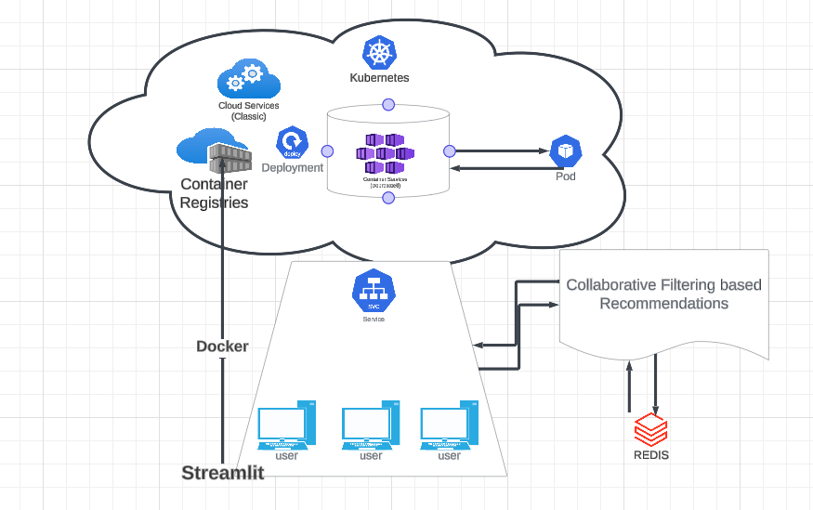
Figure 5 Cloud-Based Game Recommender Architecture
The diagram above shows the envisioned architecture of the game recommender system.

Tools and techniques
In the development of the game recommender system, a GitHub repository titled "Cloud-Based-Movie-Recommender-System" was utilized as a critical research tool. This repository served as a foundational resource, offering insights into system architecture, cloud integration, and recommendation algorithms specifically designed for cloud environments. Adaptations were made to suit the unique requirements of gaming dynamics, including modifications to the recommendation logic and enhancements for cloud deployment to support real-time interactions. These adjustments facilitated a deeper engagement with cloud services, including Kubernetes for orchestration and Redis for database management, ensuring that the system was both responsive and scalable. The repository significantly streamlined the development process, providing a proven framework that not only enhanced the system’s functionality but also enriched the technical approach to cloud-based application development.
Python and Shell scripting played pivotal roles, underpinning the project's backend and automation processes. Python's versatility was leveraged extensively, with libraries such as Pandas for data manipulation and analysis, which facilitated the handling of complex datasets integral to the recommendation algorithms. Serialization and deserialization of objects were managed through the pickle and Json pickle libraries, ensuring seamless state management and data interchange between processes. Additionally, the hashlib library was crucial for securing user data, providing robust hashing functionalities to maintain data integrity and security. Shell scripting complemented these operations by automating deployment tasks, streamlining the execution of Python scripts, and managing interactions with the cloud environment. This combination of Python for core functionalities and Shell for orchestration exemplified an efficient use of programming tools to enhance the system's reliability and performance in a cloud-based setting.
PyCharm served as the integrated development environment (IDE) of choice, providing a robust platform that supported the entire development lifecycle. PyCharm, known for its powerful code analysis capabilities, helped streamline the coding process with features like code completion, error detection, and automated refactoring. This environment was particularly beneficial for handling Python code, which is the backbone of the recommender system. The IDE's integrated tools for version control, such as its native support for Git, allowed for efficient management of changes and collaboration among developers. PyCharm’s database tooling also offered seamless database management, which was crucial for interacting with the system's backend databases efficiently. Furthermore, PyCharm’s virtual environment management simplified the task of managing Python packages and dependencies, ensuring that the development environment remained clean and consistent across various stages of the project. This choice of IDE significantly enhanced productivity and reduced the potential for errors, facilitating a smooth development process for the game recommender system.
The game recommender system was developed using a suite of advanced server technologies to ensure efficient operation, scalability, and robustness. Flask, a Python-based micro web framework, was chosen for its lightweight and flexible nature, allowing for quick development of RESTful APIs that handled dynamic requests and served game recommendations. For real-time data handling and high-speed retrieval, Redis, an in-memory data structure store, was utilized, significantly enhancing user interaction speeds. The entire application was containerized using Docker, which encapsulated all dependencies in a single package, streamlining deployment across different environments and reducing compatibility issues. The system was hosted on Microsoft Azure, which provided a cloud infrastructure capable of high availability, load balancing, and auto-scaling to manage varying user loads efficiently. Furthermore, Kubernetes was employed for orchestrating container deployment, scaling, and management, automating application operations to ensure efficient resource use and consistent uptime. This integration of technologies facilitated a resilient backend architecture that supported complex algorithm processing and sustained a large user base without sacrificing performance.

Unit testing
Test plan for Cloud-Based Game Recommender System
The purpose of this test plan is to outline the strategies and efforts to validate the functionality, performance, and security of the Cloud-Based game Recommender System.
Test Items
- Accuracy and relevancy of game recommendations.
- User authentication processes
- Database interactions
- Cloud service integration and deployment functionalities.
- User interface elements and interactions.
- Integration with external APIs for game data.
Features to be Tested
- The algorithm's recommendation logic against a set of known preferences.
- Secure login/logout functionality.
- Database consistency when handling user input and recommendation data.
- Response times and resource usage within the cloud-hosted environment.
- API data retrieval and error handling.
Approach
- Functional Testing: To validate each function of the application operates in conformance with the requirement specification.
- Performance Testing: To determine the responsiveness and stability of the application under various load conditions.
- Security Testing: To identify vulnerabilities and ensure data protection measures are effective.
- Usability Testing: To ensure the application is intuitive and conforms to user experience standards.
- Compatibility Testing: To ensure the application works across different browsers and devices.
- Integration Testing: To verify the interfaces between components and external systems function as expected.
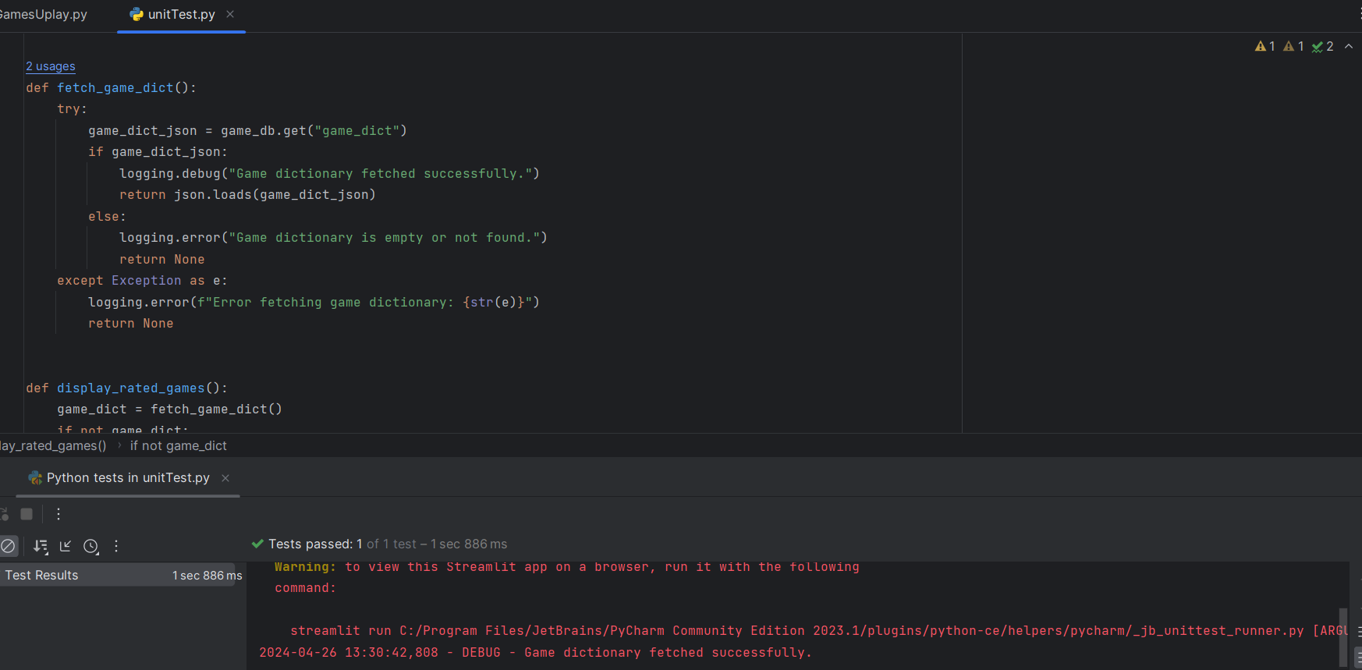
Figure 6: Unit Testing
The testing phase of the Cloud-Based Game Recommender System demonstrated that some of features and functionalities were operating as intended. This outcome can be attributed to a well-planned development process that emphasized iterative testing and integration. To consolidate the success of the functional features, the next steps will involve refining these components based on the insights gathered during testing. The streamlit application was not successful in its cloud deployment but was operational on the localhost machine. The various unit test carried out ensured that the game database was being populated but unfortunately there was a failure to display the games.
For example, while the recommendation algorithms performed acceptable under test conditions, continuous refinement will enhance their accuracy and relevance by incorporating a broader dataset and more sophisticated machine learning techniques. User authentication and database interactions, which showed robust performance, will be subjected to further security and stress tests to ensure they can handle increased loads and potential security threats as the system scales. Moreover, the integration with cloud services, which was successful, will be optimized for cost and performance, ensuring that the system remains efficient and responsive under different user loads. By building on the existing functional foundation, the system can be optimized for better performance, security, and user satisfaction. This approach ensures not only maintenance of current functionalities but also paves the way for future enhancements and scalability.

Project Planning
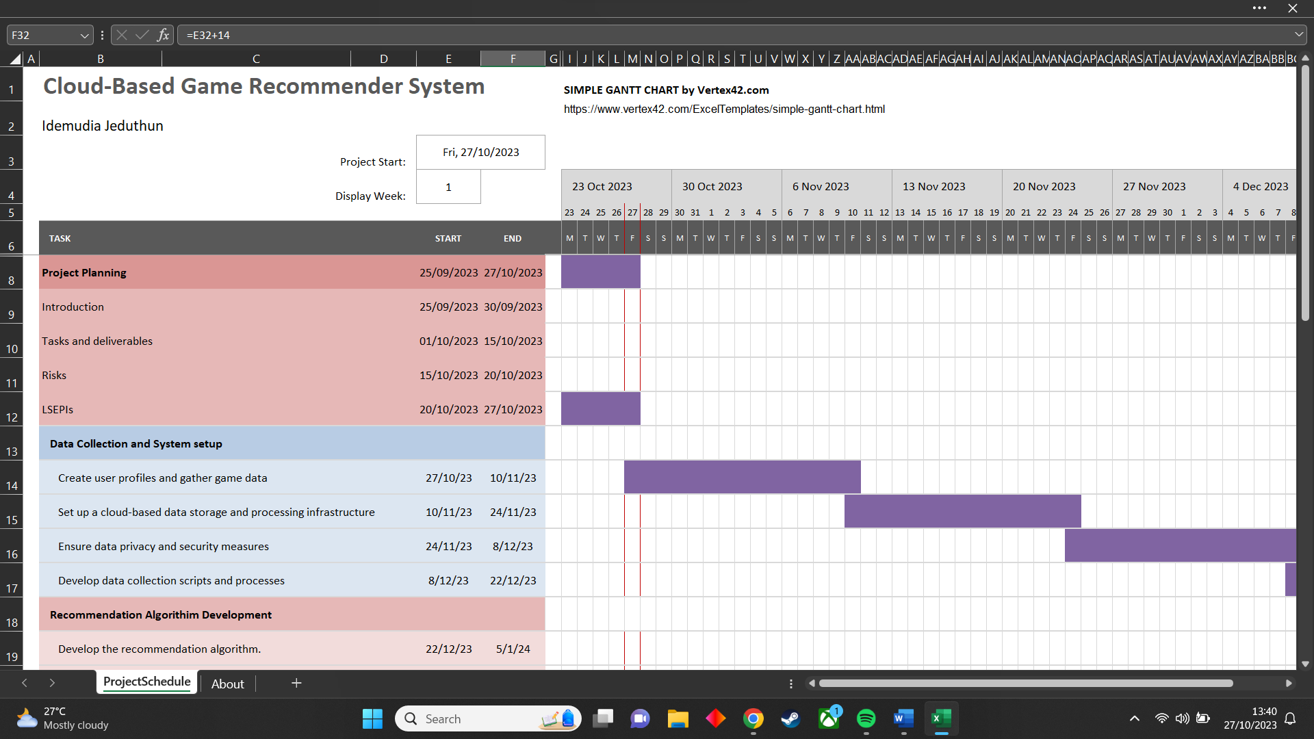
Figure 7: Project planning Gantt chart 1
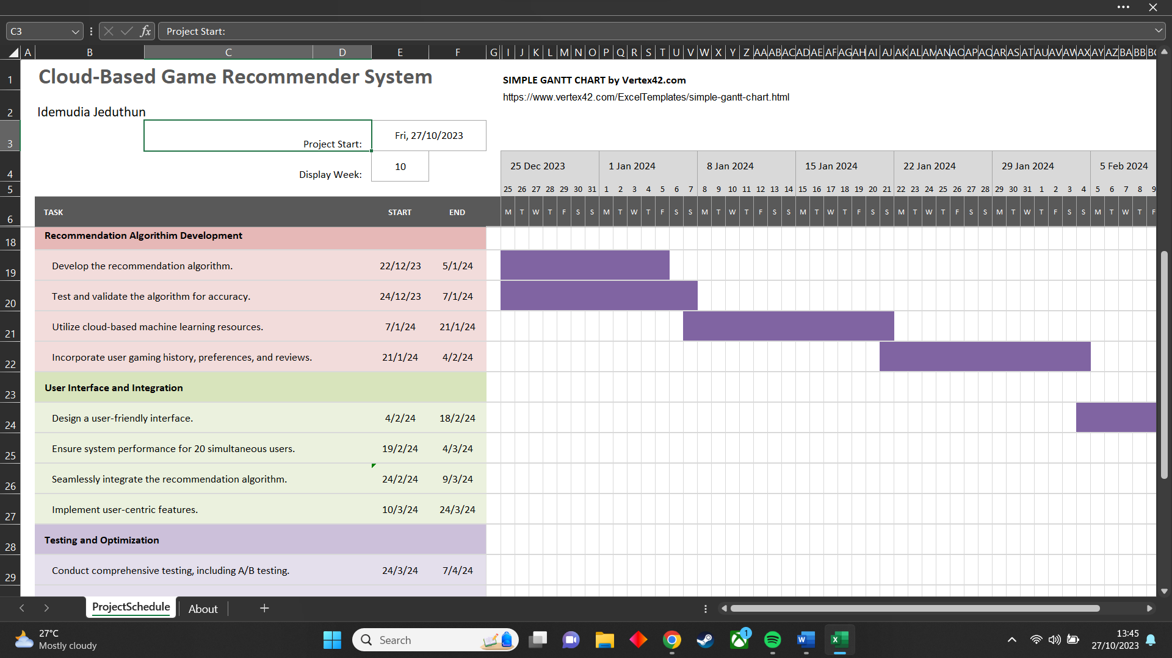
Figure 8: project planning Gantt chart 2
The implementation of the cloud-based game recommender system was meticulously planned and executed over a seven-month period, with each phase of development encapsulated by precise milestones, as depicted in the project's Gantt charts.
The initial two months were dedicated to data collection and system setup, a foundational phase that entailed the creation of user profiles, gathering of game data, and establishment of a robust cloud-based infrastructure for data storage and processing. Privacy and security measures were instituted to ensure the integrity and confidentiality of user data.
By the end of the fourth month, the recommendation algorithm development was meant to be complete, but the project ran late. This intricate process involved developing the algorithm, validating its accuracy, and integrating user gaming history, preferences, and reviews. The utilization of cloud-based machine learning resources was key to enhancing the algorithm's performance.
The user interface and integration work spanned up to the sixth month, during which the focus was on designing an intuitive and user-friendly interface that could support simultaneous multiple users, ensuring the recommendation algorithm's seamless integration and the implementation of user-centric features.
In the final stretch leading up to the seventh month, testing and optimization were planned to be conducted, but with the project running late the recommendation algorithm and user interface were carried over to the last month. Comprehensive A/B testing and other rigorous testing methods to ensure the system's performance and reliability were all part of the final phase of the project development. This final phase was critical in confirming that the system was ready for deployment and use in a live environment.
Despite meticulous project planning, which identified potential technical challenges and data security concerns, there was an oversight in formulating contingency plans for such technical issues. As a result, the project encountered setbacks that hindered its full development and precluded its successful deployment on Microsoft Azure. Consequently, the game recommender system's functionality was restricted to local operation on a designated machine, falling short of its envisioned cloud-based capabilities.

CHAPTER 5

RESULTS

Results: Success Criteria and Achievements
System Setup
Data Collection and Storage Infrastructure: Successfully created user profiles and collected game data. Set up a cloud-based data storage and processing infrastructure to handle the collected data efficiently.
Data Privacy and Security Measures: Implemented robust data privacy and security measures to safeguard user information and ensure compliance with relevant regulations.
Recommendation Algorithm Development
Algorithm Development: Developed a collaborative filtering recommendation algorithm tailored to the gaming domain. The algorithm leverages user gaming history, preferences, and reviews to deliver personalized game recommendations.
Testing and Validation: Conducted thorough testing and validation of the recommendation algorithm to ensure accuracy and effectiveness in suggesting relevant games to users.
Utilization of Cloud-Based Machine Learning Resources: Leveraged cloud-based machine learning resources to enhance the performance and scalability of the recommendation algorithm.
User Interface and Integration:
User-Friendly Interface: Designed and implemented a user-friendly interface that facilitates easy navigation and interaction for users.
System Performance: Ensured system performance for up to 20 simultaneous users, providing a seamless experience without compromising responsiveness.
Seamless Integration of Recommendation Algorithm: Successfully integrated the recommendation algorithm into the user interface, allowing users to access personalized game recommendations seamlessly.
Implementation of User-Centric Features: Incorporated user-centric features to enhance the overall user experience and engagement with the platform.
Testing and Optimization:
Comprehensive Testing: Conducted comprehensive testing, including A/B testing, to evaluate system functionality, performance, and user satisfaction.
Optimization: Optimized system responsiveness and accuracy based on feedback and iterative testing, ensuring an optimal user experience.
Challenges and Lessons Learned
Scalability and Maintenance:
Limited Scalability on Azure Cloud: Despite efforts to scale the project on Microsoft Azure Cloud, encountered challenges that hindered successful deployment and scalability.
Lessons Learned: Identified areas for improvement in scalability planning and cloud infrastructure management. Recognized the importance of robust scalability strategies to accommodate a growing user base and game library effectively.
Future Directions
Enhanced Scalability Planning: Plan to revisit scalability strategies and explore alternative cloud platforms or scaling techniques to address the scalability challenge effectively.
Continuous Optimization: Commit to ongoing optimization efforts to further enhance system performance, accuracy, and user satisfaction.
Expansion of Features: Explore the addition of new features and functionalities to enrich the user experience and offer more personalized gaming recommendations.
Conclusion
Despite facing challenges in scalability and maintenance, the project successfully achieved significant milestones in system setup, recommendation algorithm development, user interface, integration, testing, and optimization. The project's results lay a solid foundation for future enhancements and improvements, ensuring continued innovation and user satisfaction in the gaming recommendation domain.

Techniques & Analysis
To assess the success of the project and ensure its robustness and effectiveness, a comprehensive testing methodology was employed. The evaluation focused on various aspects, including functionality, performance, security, integration, and scalability. The following testing techniques were utilized:
Unit Testing
Unit testing was conducted on critical components of the project, such as the recommendation algorithm and database interactions.
Ensured that individual units of code functioned correctly and produced the expected results.
Verified that the recommendation algorithm provided accurate and relevant game recommendations based on user preferences.
Functional Testing
Functional testing was performed to validate the overall functionality of the system, including user registration, login, game recommendation, and profile management features.
Checked that all system functionalities operated as intended and met the specified requirements.
Performance Testing
Performance testing aimed to evaluate the responsiveness and efficiency of the system under normal and peak load conditions.
Assessed the system's response time, throughput, and resource utilization to ensure optimal performance for users.
Security Testing
Security testing was conducted to identify and mitigate potential vulnerabilities and threats to user data and system integrity.
Verified that user authentication, data encryption, and access control mechanisms were effectively implemented to protect sensitive information.
Integration Testing
Integration testing focused on verifying the seamless integration of various system components, including the recommendation algorithm, database, and user interface.
Ensured that all components worked together cohesively to deliver a unified and functional user experience.
Scalability Testing
Scalability testing assessed the system's ability to handle increasing user load and growing data volumes.
Tested the system's performance and stability under simulated high-traffic scenarios to determine its scalability limits.

Evaluation Results
Unit Testing: Successful completion of unit tests confirmed the correctness and reliability of key system functionalities, including the recommendation algorithm.
Functional Testing: All system functionalities were validated, demonstrating that the project met the specified requirements and user expectations.
Performance Testing: The system exhibited satisfactory performance metrics, with acceptable response times and resource utilization levels under normal operating conditions.
Security Testing: Robust security measures were implemented, safeguarding user data and system assets against potential security threats and vulnerabilities.
Integration Testing: Seamless integration of system components ensured a cohesive and consistent user experience across all features and interactions.
Scalability Testing: While the project succeeded in most testing areas, scalability testing revealed limitations in the system's ability to scale effectively, particularly when faced with high user demand and data growth.
Conclusion
The project evaluation, conducted through a rigorous testing methodology, highlighted significant successes in functionality, performance, security, and integration. However, challenges were identified in scalability, indicating the need for further improvements and optimization in handling growing user bases and data volumes. Overall, the project's success in meeting the majority of testing criteria underscores its potential to deliver personalized game recommendations effectively and enhance user engagement in the gaming domain. The main issue regarding the success of this project was due to lack of time management and code complexity. Regardless of the issues, the project was still able to gain some achievements.

CHAPTER 6

CONCLUSION

6.1 Conclusions
In conclusion, the Game Recommender System project successfully demonstrates the practical application of collaborative filtering algorithms to provide personalized content recommendations. Through the implementation of a user-friendly interface via Streamlit and the robust backend processing with Flask and Redis, the system adeptly handles user interactions and data management. The architecture leverages cloud services to ensure scalability and reliability, reflecting industry-standard practices for modern web applications.
The project's achievements include the development of an efficient recommendation engine that tailors suggestions to individual user preferences, thus enhancing user engagement. It also exemplifies the use of containerization with Docker, and orchestration with Kubernetes, which underscores the project's readiness for deployment in a cloud-based environment. The deployment of Streamlit in a cloud-based environment was unsuccessful. Although the envisioned system was not fully implemented future enhancement and improvement are yet conceivable.
Future enhancements may focus on incorporating more sophisticated machine learning algorithms, expanding the database to include a wider array of games, and refining the user interface for an even more intuitive experience. This project serves as a foundation for further exploration into the realm of recommendation systems and their potential to transform user experiences in digital platforms.

6.2 Future work
The conclusion of the Game Recommender System project has laid a substantial groundwork for a versatile and user-friendly platform that introduces viewers to games that align well with their preferences. However, to enhance the system's capability and enrich user engagement, a few potential improvements stand out.
Future advancements could focus on the amalgamation of various recommendation algorithms. By incorporating deep learning and neural networks, the system could discern subtle patterns and correlations in user behaviour, offering more personalized recommendations. This could be combined with natural language processing (NLP) techniques to analyse game reviews and plot summaries, providing recommendations that understand the complexities of users’ desires and genre preferences.
In parallel, expanding the game dataset would ensure inclusivity and diversity, catering to a global audience with varied tastes. Adding user demographic data would enable the system to tailor recommendations according to age, geographic region, or even cultural interests. With an expanded database, performance optimization becomes crucial. Techniques like dimensionality reduction and distributed computing could significantly enhance the system's efficiency, ensuring that even with the increased data load, the user experiences swift and responsive interactions.
User experience lies at the heart of the system's success. Developing an adaptive user profile that evolves with each interaction could create a highly personalized interface. Coupled with an improved UI that emphasizes minimalistic design and ease of use, the system could offer a seamless and enjoyable browsing experience. Advanced filtering options, interactive elements, and responsive design would further enhance accessibility and usability across devices.
As the system grows, so does the need for robust security and privacy measures. Ensuring the highest standards of data protection and giving users control over their information will build trust and credibility. Transparent policies on data usage and privacy should be clear and accessible.
Considering scalability from the outset is crucial. A system designed for expansion will be able to handle increased traffic and maintain performance standards. Adopting a microservices architecture could provide the flexibility needed for such scaling and for the continuous integration of new features.
Lastly, establishing a feedback loop is vital for continuous improvement. By actively learning from user interactions and feedback, the system can regularly refine its recommendation models. By strategically enhancing the system in these domains, the project can maintain momentum, staying abreast of technological advancements and user expectations. This ongoing evolution will solidify the project's position as a cutting-edge tool in the ever-expanding domain of content recommendation.

6.3 Legal, Social, Ethical and Professional Issues
The main legal concern is data privacy and security. In compliance with data protection regulations like GDPR and CCPA, protecting user data privacy is essential. The project will prioritize the implementation of password encryption and security measures to safeguard sensitive user information. The passwords will be hashed and stored in the backend making access impossible. This project will necessitate permissions for the use of game data, images, and descriptions to avoid copyright infringement. This project will strive to be transparent in obtaining users for data collection, profiling, and personalized recommendations. There will be an adherence to the terms of service of third-party services and APIs as this is crucial to prevent legal consequences. This project will include disclaimers that clarify that users are responsible for their own actions and choices as it doesn’t promote cheating or other illegal activities.
The project's social implications are profound. This project will ensure fairness and there will be no bias in the recommendation algorithm, as biased recommendations can perpetuate discrimination based on attributes like race or gender. This project will avoid filter bubbles as this is limiting users' exposure. The project has a social responsibility to encourage diversity in content recommendations. Additionally, it must consider the potential for encouraging addiction or unhealthy gaming behaviour and strive for responsible recommendations that promote balanced gaming experiences. Furthermore, this project will be mindful of directing users away from toxic gaming communities that foster cyberbullying and other negative behaviours by showing the reviews.
The project’s success is dependent on ethical issues. Transparency is essential for ethical practises, and the project will be transparent about how recommendations are generated and how user data is utilized. Respecting user autonomy by obtaining informed consent for data collection and personalized recommendations is ethically responsible. Data retention policies will align with ethical standards. The project will also address the ethical implications of recommendation algorithms, particularly when they influence user choices and behaviours.
What effects the LSEPI’s will have on people?
In terms of their impact on people, it's important to recognize that the recommendations generated by the system can have a direct influence on users' gaming choices and behaviours. Therefore, there is a responsibility to ensure that these recommendations are fair, unbiased, and promote positive and responsible gaming habits. Moreover, user data handling and privacy practices will prioritize the protection of individuals' personal information. The project's success will not only be measured in technical achievements but also in its ability to uphold these legal, social, ethical, and professional standards to the benefit of individuals and society.

6.4 Reflections on skills developed
Through my study in NTU, I have gained proficiency in web development, data science and management, full-stack development, and artificial intelligence. I am now knowledgeable in various programming languages such python, java, JavaScript, C++, HTML/CSS and so on. Reflecting on the complexity and the interdisciplinary nature of building a game recommender system, there is a spectrum of skills that I gained which is not only critical to a full-stack developer but also to my targeted career trajectory within the gaming industry, particularly one that intersects with the rapidly advancing field of artificial intelligence. The completion of this project lead to me gaining a diverse skill set in project management and software development both of which will be required for industry experience.
Technical Skills
In the course of this project, I enhanced my capabilities in full-stack development, especially with Python and Flask, laying a strong foundation for both client and server-side proficiency. My engagement with cloud technologies, particularly within Microsoft Azure's suite, endowed me with critical knowledge in cloud infrastructure management, a skillset that aligns with the requirements of modern software development environments.
The incorporation of machine learning techniques, vital in the realm of artificial intelligence, sharpened my algorithmic acumen, preparing me for the intricacies of AI deployment in gaming. My practical experience with collaborative filtering algorithms fortified my conceptual understanding of AI, an expertise increasingly sought after in the gaming industry.
Data science was another domain of significant growth for me. I developed competencies in data preprocessing, similarity metrics application, and algorithmic performance evaluation, all of which are instrumental in structuring data-driven game development strategies. Moreover, my proficiency in managing databases was elevated through direct experience with Redis, a NoSQL database that is pivotal for managing large-scale, dynamic datasets in gaming applications.
The project also honed my skills in UI/UX design, emphasizing the importance of user-centric interfaces in game development—a principle that enhances user engagement and satisfaction. These newly acquired skills not only match the technological trends of the gaming industry but also position me well for a future where artificial intelligence plays a central role in creating immersive gaming experiences.
Soft Skills
Throughout the development of the game recommender system, I honed key soft skills essential for a comprehensive approach to complex projects. Problem-solving was at the forefront of my learning curve; tackling the myriad challenges that arose during the system's development not only enhanced my troubleshooting skills but also my ability to devise effective and innovative solutions. This skill was critical in addressing bugs and optimizing system performance.
Project management was another area of significant development. By juggling various facets of the project, from initial design to final deployment, I improved my capacity for time management, resource allocation, and prioritization. This was pivotal in maintaining project timelines and ensuring resource efficiency, skills that are indispensable in any technology-driven workplace.
Moreover, the use of Git for version control and systematic unit testing were instrumental in enhancing my technical proficiency. These practices refined my approach to codebase management in a collaborative environment and ensured robustness in system integration and functionality. This not only prepared me for managing multi-developer projects but also ingrained a meticulous attention to detail through continuous testing and iteration.
Additionally, the task of system design analysis fostered a deep level of analytical thinking. Designing a cohesive system architecture required a thorough understanding of how various components interact within the system, ensuring seamless integration and optimal performance. This aspect of the project sharpened my analytical skills and my ability to synthesize complex information, preparing me for roles that require high-level decision-making and system evaluation in the tech industry.

REFERENCES
González-González, C.S., Toledo-Delgado, P.A., Muñoz-Cruz, V. and Arnedo-Moreno, J. (2022). Gender and Age Differences in Preferences on Game Elements and Platforms. Sensors (Basel), [online] 22(9), pp.3567–3567. doi: https://doi.org/10.3390/s22093567.
Leroux, P., Dhoedt, B., Demeester, P. and Filip De Turck (2012). Performance Characterization of Game Recommendation Algorithms on Online Social Network Sites. Journal of Computer Science and Technology/Journal of computer science and technology, [online] 27(3), pp.611–623. doi: https://doi.org/10.1007/s11390-012-1248-6.
‌Takács, G., Hu, G., Hu, P., Németh, B., Bme, B., Hu, Hu, T., Frasconi, P., Kersting, K., Toivonen, H. and Tsuda, K. (2009). Scalable Collaborative Filtering Approaches for Large Recommender Systems István Pilászy * Domonkos Tikk *. Journal of Machine Learning Research, [online] 10, pp.623–656. Available at: https://www.jmlr.org/papers/volume10/takacs09a/takacs09a.pdf.
Resnick, P. and Varian, H.R. (1997). Recommender systems. Communications of the ACM, 40(3), pp.56–58. doi:https://doi.org/10.1145/245108.245121.
C. BharathiPriya, Akash Sreenivasu and Kumar, S. (2021). Online Video Game Recommendation System Using Content And Collaborative Filtering Techniques. 2021 International Conference on Advancements in Electrical, Electronics, Communication, Computing and Automation (ICAECA). [online] doi:https://doi.org/10.1109/icaeca52838.2021.9675508.
Leroux, P., Dhoedt, B., Demeester, P. and Filip De Turck (2012). Performance Characterization of Game Recommendation Algorithms on Online Social Network Sites. Journal of Computer Science and Technology/Journal of computer science and technology, [online] 27(3), pp.611–623. doi:https://doi.org/10.1007/s11390-012-1248-6.
Burke, R. (2002). User modeling and user-adapted interaction, [online] 12(4), pp.331–370. doi:https://doi.org/10.1023/a:1021240730564.
Herlocker, J.L., Konstan, J.A., Terveen, L.G. and Riedl, J.T. (2004). Evaluating collaborative filtering recommender systems. ACM Transactions on Information Systems, [online] 22(1), pp.5–53. doi:https://doi.org/10.1145/963770.963772.
Goldberg, D., Nichols, D., Oki, B.M. and Terry, D. (1992). Using collaborative filtering to weave an information tapestry. Communications of the ACM, [online] 35(12), pp.61–70. doi:https://doi.org/10.1145/138859.138867.
AmitProspeed (2020). GitHub - AmitProspeed/Cloud-Based-Movie-Recommender-System: [online] GitHub. Available at: https://github.com/AmitProspeed/Cloud-Based-Movie-Recommender-System#readme.
Mell, P. and Grance, T. (2011). The NIST Definition of Cloud Computing Recommendations of the National Institute of Standards and Technology Special Publication 800-145. [online] Available at: https://faculty.winthrop.edu/domanm/csci411/Handouts/NIST.pdf.
Shani, G. and Asela Gunawardana (2010). Evaluating Recommendation Systems. Springer eBooks, [online] pp.257–297. doi:https://doi.org/10.1007/978-0-387-85820-3_8.
Hoa Xuan Nguyen, Zhu, S. and Liu, M. (2022). A Survey on Graph Neural Networks for Microservice-Based Cloud Applications. Sensors, [online] 22(23), pp.9492–9492. doi:https://doi.org/10.3390/s22239492.
‌

‌
‌

‌

‌

‌

‌

‌

‌

‌

‌

